Basic Image Manipulation

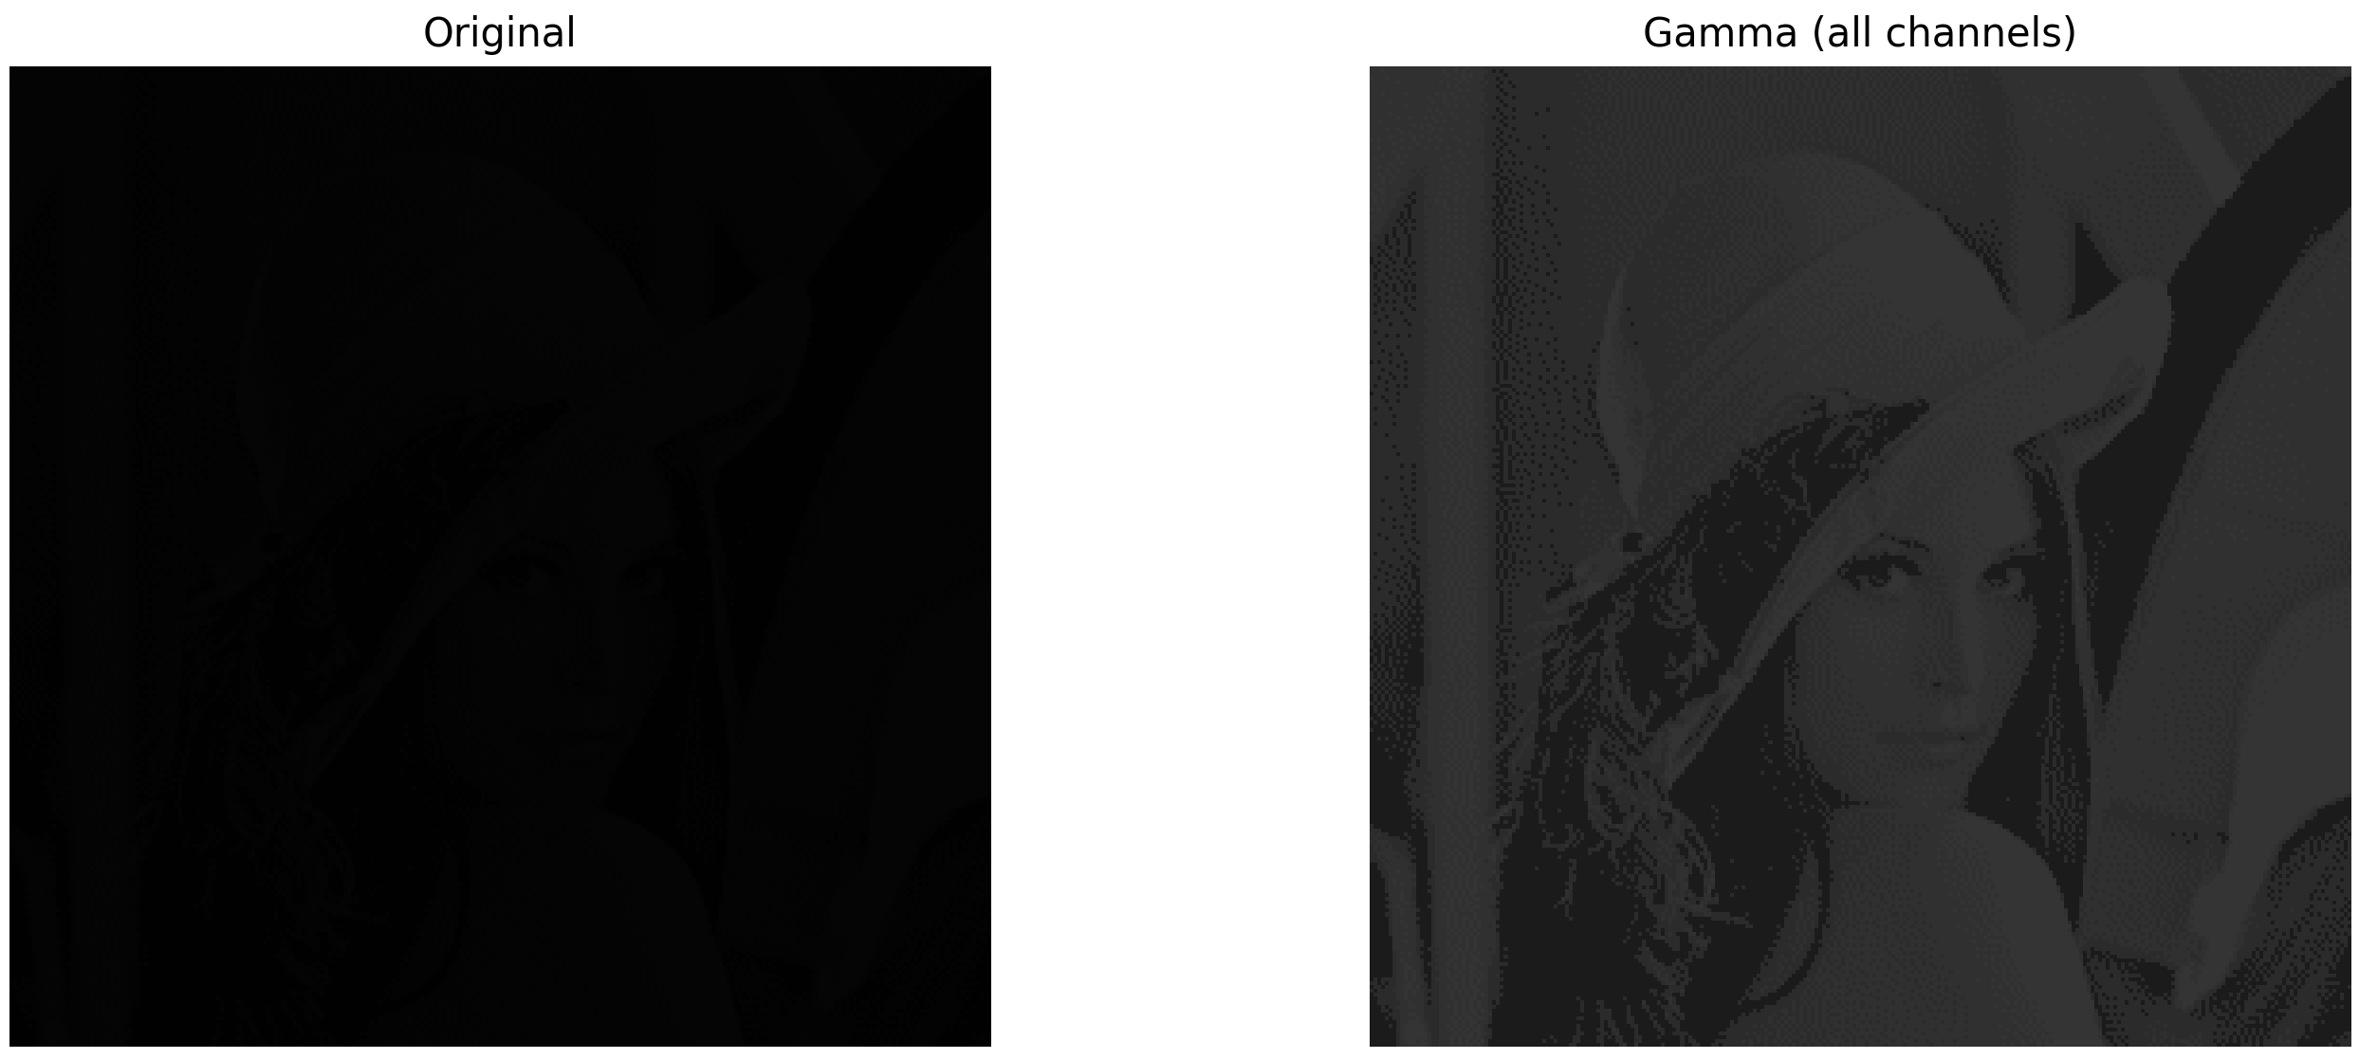
„reallyBlack.png“

Is it really black? Prove or disprove it and justify your answer.
With the non-linear gamma-brightness-correction I adjusted the brightness of each RGB channel. We can see that the image is not all black.

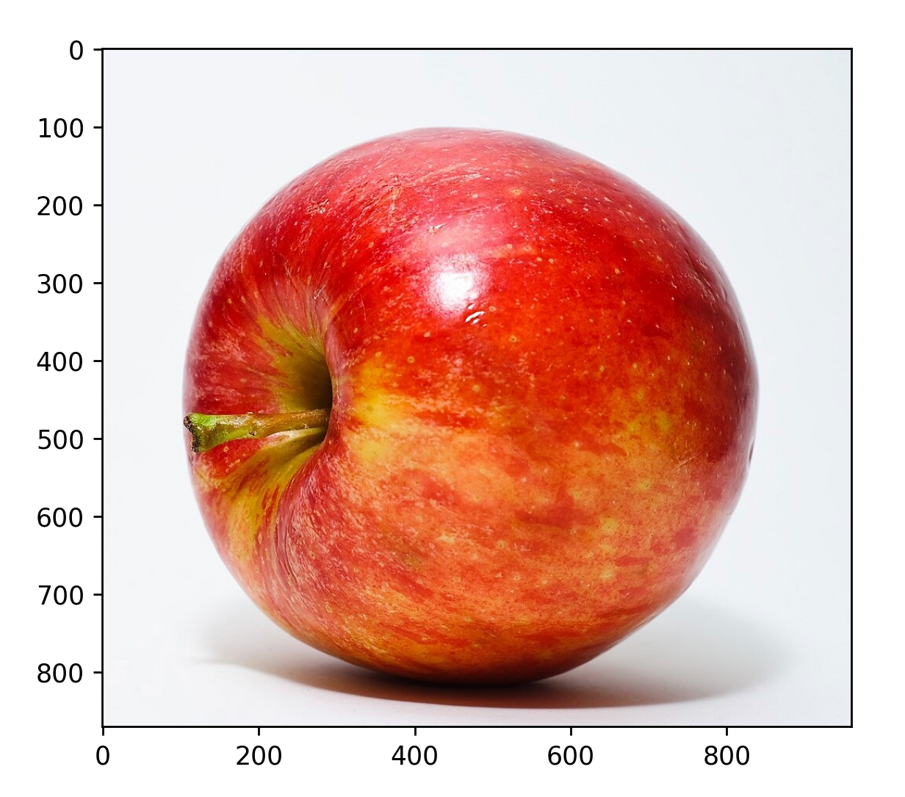
Apple image

What was the apple’s original color?
The apple’s original color was red.

How can you fix the issue?
The image is stored as RGB, but is displaying a BGR image. If I use cv2.imread() it reads the image and converts from RGB to BGR. Therefore it transforms the image back to it’s original colors.

Capture a color image

Image properties
- Data type: avif, Size: 16.1 KB
- Dimension: height, width, channels 650 px, 1600px, 3 channels (RGB)
- radiometric resolution: 0-255 values 8-bit image

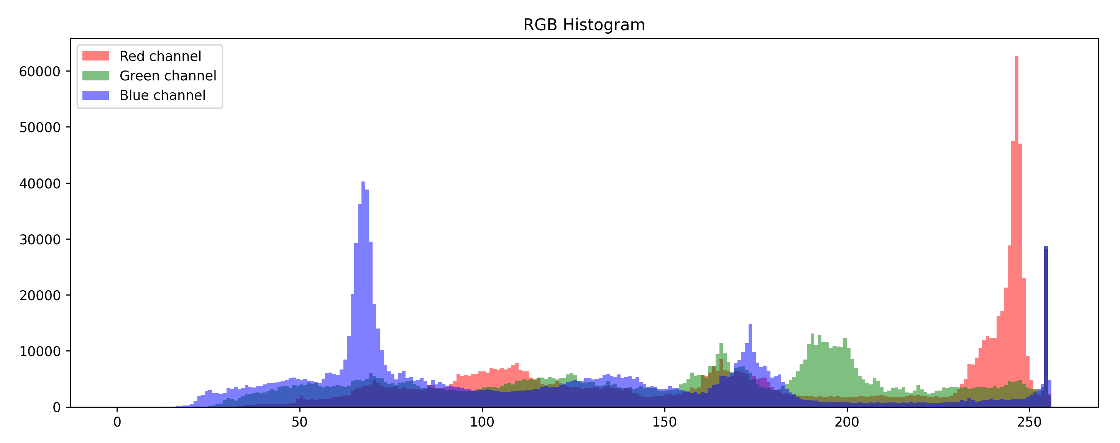
RGB histograms

- High-brightness reds and blues
- Mid-brightness greens
- Significant dark blues

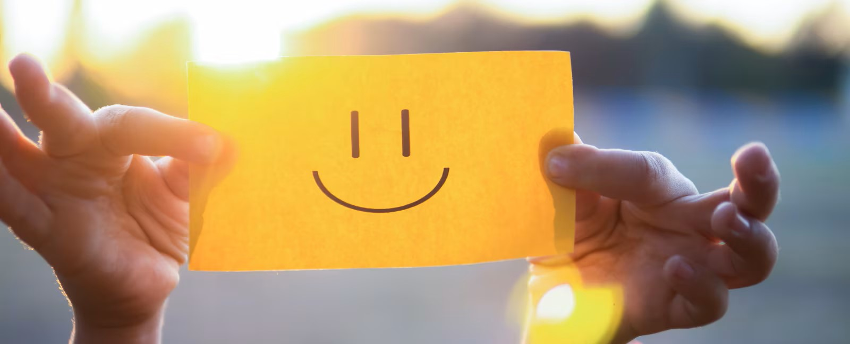
Bright yellow paper High red + green, low blue
Sunlight/backlight Extreme brightness spikes
Blueish background Strong mid/high blue values
Hands/skin tones Red-leaning midtones

Grayscale experiments

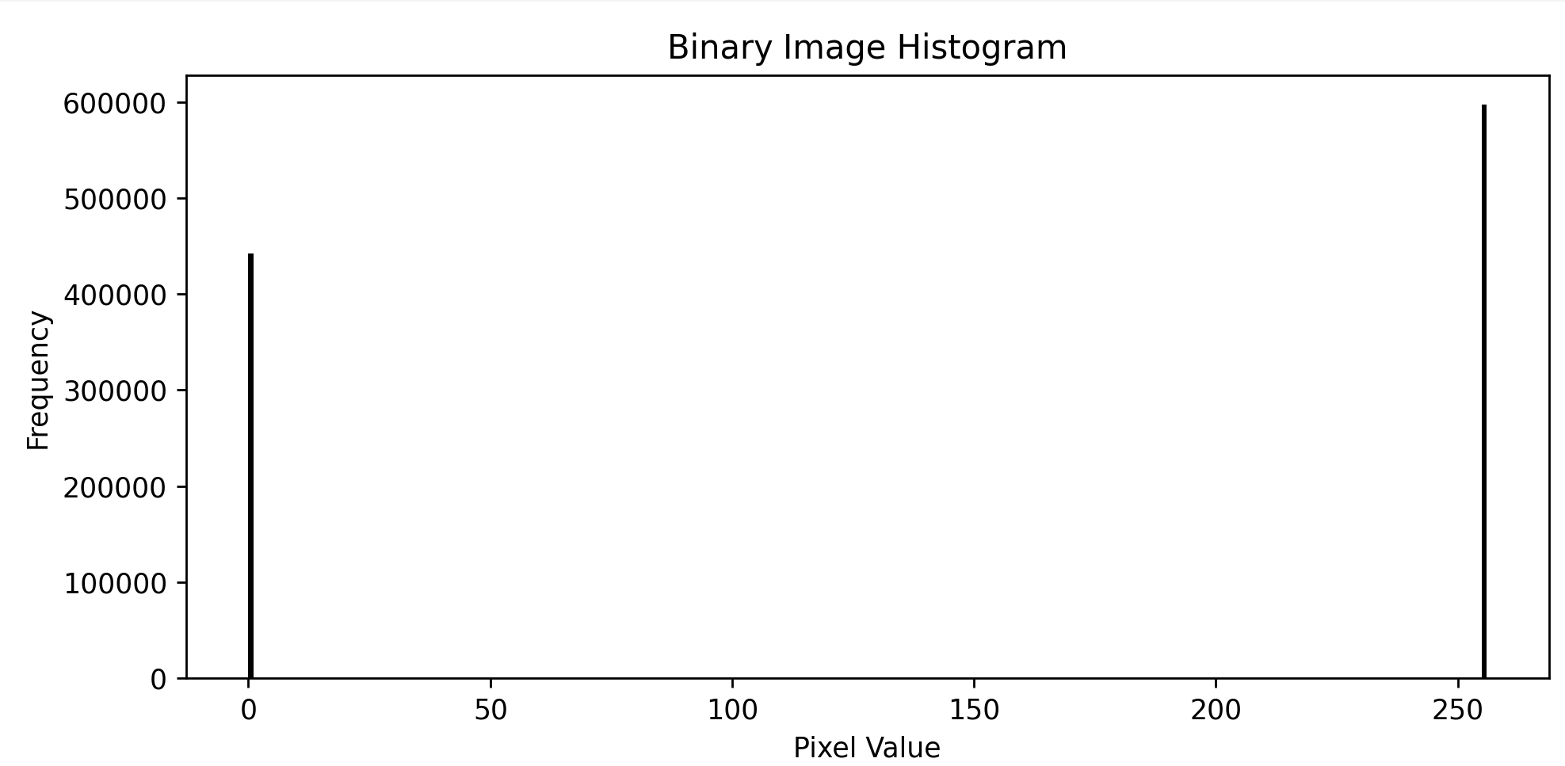
What are the dynamic range and contrast of a binary image?
- 0black
- 255white
- contrastblack and white (Thresholding)
Dynamic range = max value – min value = 255-0 = 255

Can image contrast always be improved? Under what assumptions?
No. In that case the image has only two contrast: black or white. The details are already saturated and can’t be recovered.
If the image’s picture occupy a small part of the full range, then the contrast can be improved through histogram stretching. That way the contrast will be evenly distributed.
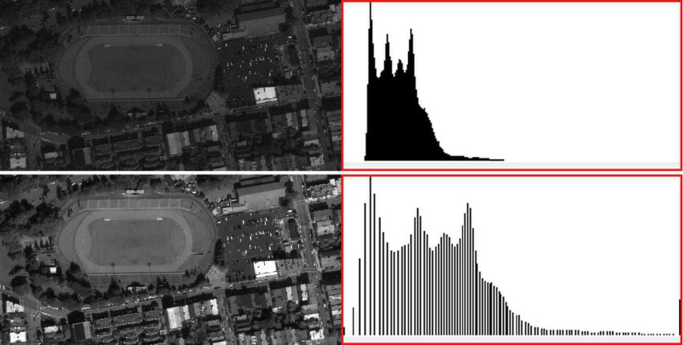

Can the dynamic range of an image always be improved?
The dynamic range can be stretched mathematically, but the real dynamic range can’t be increased. This does not create new information.

Can every real-world color be represented as an RGB triple?
No. The human vision sees more colors than RGB. Some real-world colors can’t be expressed only by RGB. They are spectral distributions, not just three numbers.

